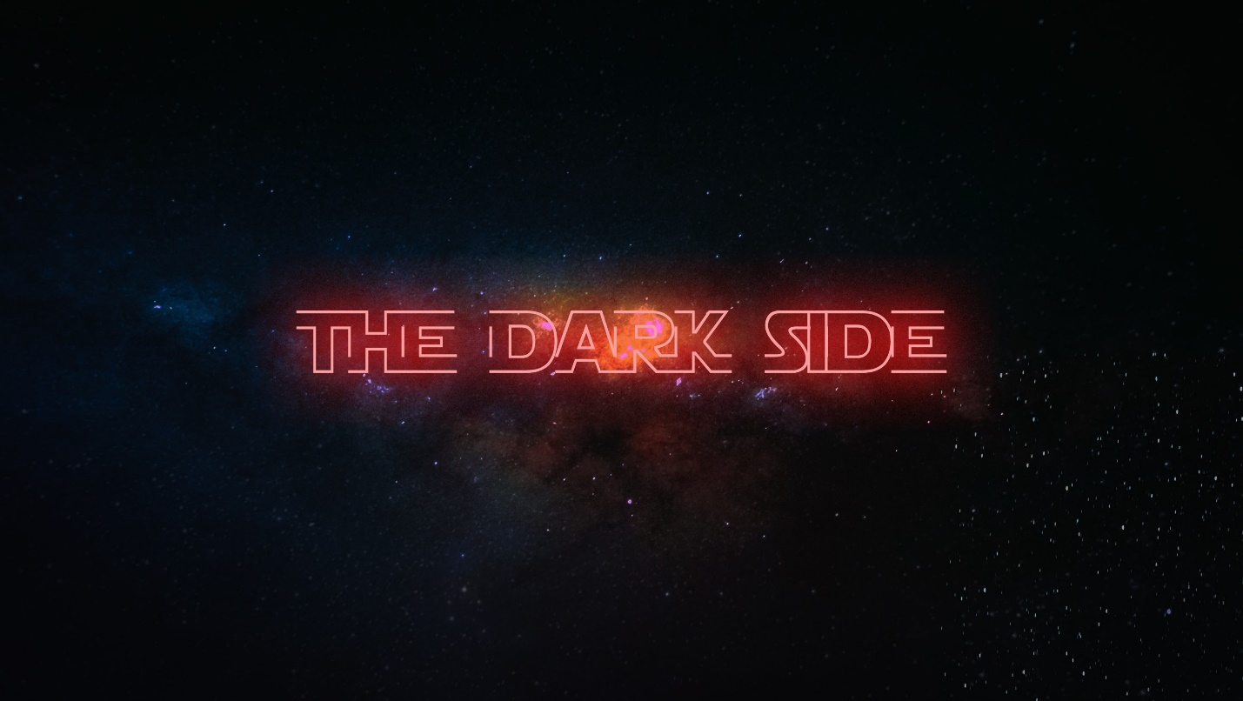**Week 4 - The Dark Side**

**LIFE/INTRO QUESTIONS (CHOOSE 1 OR 2)**

* What are the top three things on your bucket list? Are you scared of any of them?
* Have you been fearful of rejection this week? How so?

**CONNECTION QUESTION**

* What is your relationship with Jesus like? If comfortable, explain.

**Sermon in a Sentence**

* Fear derails us from the purpose God has for us, which is to further the Kingdom!

**SCRIPTURE**

* **Luke 4:18-19** “The Spirit of the Lord is on me, because he has anointed me to proclaim good news to the poor. He has sent me to proclaim freedom for the prisoners and recovery of sight for the blind, to set the oppressed free, to proclaim the year of the Lord’s favor.”
* What is Jesus saying in this scripture?

**DISCUSSION QUESTIONS**

* How often do you find yourself embarrassed when talking about Jesus to others?
* What struggles in your own life do you feel are too powerful for you or you’re too fearful of them? Explain if comfortable.
* Do you feel as though you have found some purpose in life? Or are you still searching?

**LIFE APPLICATION**

We want students to walk away with 1 or 2 things they are going to do SOON to apply what they discussed.

* If you get embarrassed talking about Jesus, what are some ways this week that you can move forward with it? Encourage them that 5 minutes of being uncomfortable can potentially change someone's life!

**TAKE IT OUT**

* Close small group out with prayer requests.
* Remind your students that Fusion is next month – they need to go to fusion.events to register!
* Refuse to let money stand in the way – check FPSLeaders.com for a scholarship application if needed.
* We will not have fpStudents next week because of Christmas, so come back the following Wednesday, Jan. 1st!